Lab 2

Binary and BCD Counters

By: Brandon Kowal, Bernard Owusu Sefah

Abstract

The purpose of the lab was to use the 7493 IC and the ETS-7000 Digital Training System to give us a better understanding of how the count sequence of the BCD. The protocol for this lab was to follow every tutorial to learn about the basic triggers and buttons. The 7493 IC functions as a 4-bit binary counter that shows, 0000, 0001, 0010…, ins sequence. The 7493 IC has outputs designated as QA, QB, QC, and QD, where QA is the least significant bit and QD is the most significant bit. The IC had 14 pinouts and the 10th pin was a ground and the 5th pin the Vcc (power supply).

Introduction

This lab is to introduce the logic integrated circuit 7493. This functions as a 4-bit binary counter that shows a 0000, 0001, 0010, 0011...., 1111 in sequence. The lab will help give a better understanding of the count sequence of binary numbers and the binary-coded decimal (BCD).

Methods

The protocol for this lab was following a step by step procedure the lab manual.

1. Insert the 7493 IC into the protoboard on the ETS 7000.

2.Establish a connection from the DC power supply and a ground terminal (GND) of the ETS-7000 to the trainer to the 7493 IC ground pin.

3. Connect a +5V output of the ETS-7000 DC power supply to the 7493 IC Vcc pin

4. Turn on the function generator and select the square waveform through the function switch of the function generator.

5. Adjust the frequency signal to 1KHz and connect the TTL mode output to the 14th pin of the 7493 IC.

6.Connect the digital channels of the MSO from D0 to D4 the various output of 7493 IC.

7. Connect digital channel D0 input to the function generator TTL mode output port.

8. Connect digital channel D1 input to the output QA of the 7493.

9. Connect digital channel D2 input to the output QB of the 7493.

10. Connect digital channel D3 input to the output QC of the 7493.

11. Connect digital channel D4 input to the output QD of the 7493.

12. Establish a ground connection for the MSO.

13. Turn on the MSO and the ETS-7000 and set the triggering mode to binary combination on channel D1 through D4.

14. Construct a table to verify the counter outputs displayed by the MSO.

15. Save all images on a storage medium.

16. Revise the connection of the protoboard to match figure 2 in the lab manual.

Fig 2. 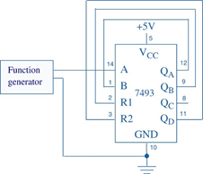

17. Keep the frequency of the function generator to 1KHz and press the single key on the MSO.

18. Adjust the resulting display so that the pattern is positioned at the left end of the screen.

20. Finally save the screen of the waveforms of the channels D0 through D4 using a computer application.

Results

Fig 1.

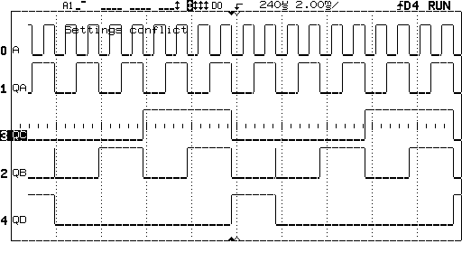

Fig 2.

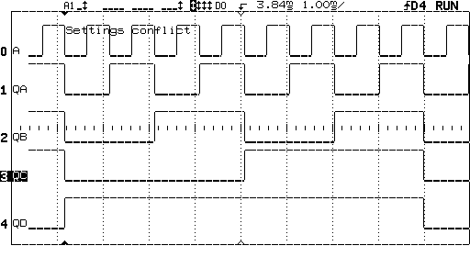

Discussion

During the Lab the IC 7493 was used. The 7493 IC has outputs designated as QA, QB, QC, and QD, where QA is the least significant bit and QD is the most significant bit. The IC 7493 has the 10th pinout for the ground and the 5th pinout is for the Vcc (power supply). With the results of the lab we could see the decimal counter goes through 10 states and resets to 0 after the 9th count. The flip-flop would occur at QA and QB would complement with the negative transition and so on till it was all ones than it resets.

Conclusion

This lab made us understand how the 7493 IC works by simulating frequency divisions of 2,4,8, and 16 are available at the Q0, Q1, Q2 and Q3 outputs. This lab also helped us learn the various pin number and function of the 7493 IC and the various clock input sections.

Appendix

Lab Attendance: Bernard Owusu Sefah: Yes Brandon Kowal: Yes

Involvement in Lab: Bernard Owusu Sefah: 50 Brandon Kowal: 50

Involvement in Lab Report: Bernard Owusu Sefah: 55 Brandon Kowal: 45

References

7493 IC Data Sheet. (n.d.). Retrieved from https://www.digchip.com/datasheets/parts/datasheet/364/7493-pdf.php?utm_source=RB-Community&utm_medium=forum&utm_campaign=how-to-get-7493-to-work